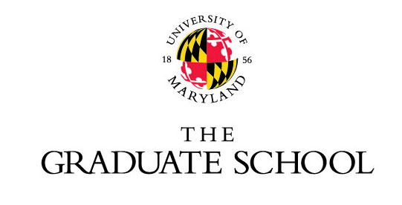

Flagship Fellowships for AY 2014 - 15

Melissa Benitez
College of Arts and Humanities, Department of American Studies
New York University, B.A.

Paul Jacob Bueno de Mesquita
School of Public Health, Department of Toxicology
Georgetown University, B.S.

Rebecca Eckert
College of Computer, Mathematical, and Natural Sciences, Department of Entomology
Kutztown University, B.S.
Penn State University, M.S.

Katelyn Esmonde
School of Public Health, Department of Kinesiology
McGill University, B.S.
Purdue University, M.S.

Zachary Glassman
College of Computer, Mathematical, and Natural Sciences, Department of Chemical Physics
Ponoma College, B.A.

Allison Greaney
College of Computer, Mathematical, and Natural Sciences, Department of Geology
University of Illinois, B.S.

Gaurav Kandlikar
College of Computer, Mathematical, and Natural Sciences, Biological Sciences Program
University of Minnesota, B.S.

Tabitha Kidwell
College of Education, Department of Curriculum and Instruction
Miami University, B.A.
Ohio State University, M.A.

Mattson Ogg
College of Behavioral and Social Sciences, Neurosciences and Cognitive Sciences Program
McGill University, B.A.

Laurel Perkins
College of Arts and Humanities, Department of Linguistics
University of Toronto, B.A.
New York University, M.M.

Kristina Stephens
A. James Clark School of Engineering, Department of Bioengineering
University of Maine, B.S.

Jessica Stern
College of Behavioral and Social Sciences, Department of Psychology
Ponoma College, B.A.

Rodman Turpin
School of Public Health, Department of Epidemiology and Biostatistics
Howard University, B.S., M.S.

Gordon Walsh
College of Arts and Humanities, Department of Art History
Fordham University, B.A.

Joshua Wayland
College of Behavioral and Social Sciences, Department of Geography
College of William and Mary, B.A.

