Postdoctoral Research Symposium
September 13, 2019

Session 1: 10:00-11:15 AM

Grant writing? Think of the review

John Bertot

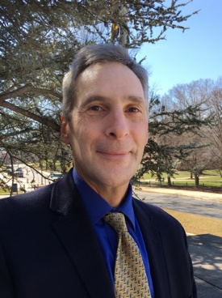
John Bertot is the Associate Provost for Faculty Affairs and a Professor in the College of Information Studies (the iSchool). Under Dr. Bertot, the Office of Faculty Affairs supports all aspects of faculty experience at the University, such as managing the APT process to ensure excellence and equity in tenure decisions, facilitating human resource functions, overseeing professional development opportunities for faculty, and advocating for faculty interests and perspectives in the leadership of the University. He has been a Professor in the College of Information Studies (iSchool) since 2008, and has served as co-director of the Information Policy & Access Center (iPAC). John served as director of the iSchool’s Master of Library Science program from July 2011-July 2015. Prior to joining the iSchool, he was Professor in the iSchool at Florida State University. His research spans information and telecommunications policy, public service innovation, digital government, and library planning and evaluation. He received his Ph.D. from the School of Information Studies at Syracuse University in 1996.

Wolfgang Losert

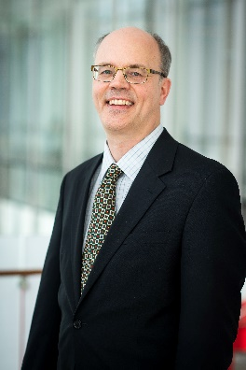
Dr. Losert is Professor of Physics, Director of the Institute for Physical Science and Technology, and Associate Dean for Research in the College of Computer, Mathematical, and Natural Sciences (CMNS) at the University of Maryland. Before his appointment as Associate Dean in 2014, Dr. Losert chaired the educational affairs committee of the University Senate, and served as Graduate Program Director of the Biophysics Graduate Program. He also led the development of modern introductory physics laboratories for life scientists. Dr. Losert's research efforts are at the convergence of physics and biology, as leader of a Data Science Core of an NIH BRAIN initiative grant, and of an AFOSR MURI team.

Susan Winter

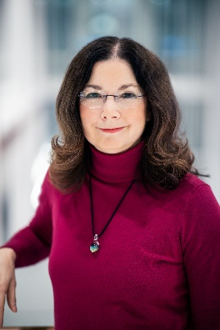
Dr. Susan Winter is the Associate Dean for Research and Co-Director of the Center for Advanced Study of Communities and Information. Her research focuses on technology and the organization of work, especially the social and organizational challenges of data reuse and collaboration among information workers and scientists acting within highly institutionalized sociotechnical systems. Her work has been supported by multiple awards from the U.S. National Science Foundation and from the Institute of Museum and Library Services. She was previously a Science Advisor in the Directorate for Social Behavioral and Economic Sciences, a Program Director, and Acting Deputy Director of the Office of Cyberinfrastructure at the National Science Foundation supporting distributed, interdisciplinary scientific collaboration for complex data-driven and computational science. She received her PhD from the University of Arizona, her MA from the Claremont Graduate University, and her BA from the University of California, Berkeley.

Iqbal Hamza

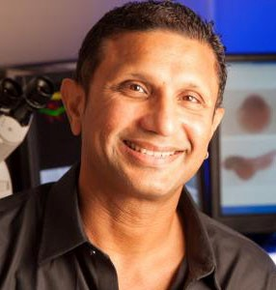
Iqbal Hamza is a Professor at the University of Maryland and has worked with trace metals as a graduate student beginning in 1991. He joined the University of Maryland in 2002 where he deliberately set out to uncover heme trafficking pathways in eukaryotes because none were known at the time. His research group identified Heme Responsive Genes (HRGs) proteins, which coordinate and integrate heme homeostasis in eukaryotes. The genetic and genomic approaches he established in C. elegans laid the groundwork for discovery of heme transport pathways in parasites. Dr. Hamza has reviewed articles for over 30 different journals; served as a standing member of the Integrative Nutrition and Metabolic Processes NIH Study Section; chaired two different Gordon Research Conferences: the Chemistry and Biology of Tetrapyrroles (2018) and the Cell Biology of Metals (2019); and is a Fellow of the American Association for the Advancement of Science.

Communicating your research to a broad audience

Linda Macri

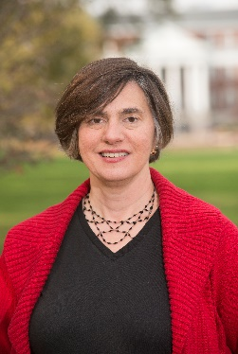
Dr. Macri is the Director of Academic and Professional Development int the Graduate School at the University of Maryland and has directed the Graduate School Writing Center since 2014. She is also the co-chair of the Consortium on Graduate Communication. Her academic interests are in composition studies, rhetorical theory, graphic novels and comics, and women's literature. She has taught a wide range of writing and literature courses, and she previously served as the director of the Academic Writing Program in the English Department.

Network strategy and importance of digital presence

Karen Lips

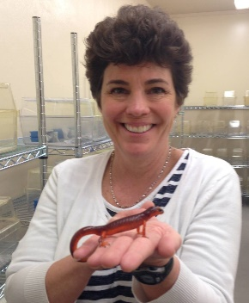
Dr. Karen Lips is Professor of Biology at the University of Maryland. She has a B.S. in Zoology from the University of South Florida, and a Ph.D. in Biology from the University of Miami. She is an ecologist who studies how global change (e.g., wildlife disease, climate change, land use) affects biodiversity of amphibians and reptiles in Latin America and the US. Dr. Lips was a Jefferson Science Fellow at the Department of State, where she worked in the Bureau of Western Hemisphere Affairs, in the Office of Public Diplomacy and Public Affairs, and where she served as an Embassy Science Fellow in Colombia. Dr. Lips is a Research Associate at the US Museum of Natural History, an AAAS Leshner Leadership Public Engagement Fellow, an AAAS Fellow, an ESA Fellow, and an Aldo Leopold Leadership Fellow. She was awarded the President's Award of the Chicago Zoological Society, a Bay and Paul Biodiversity Leadership Award, the Sabin Amphibian Conservation Award in 2012, and the inaugural UMD Impact Communicator Award.

Session 2: 11:30 AM-12:45 PM

Working on a visa? Perspectives for international postdocs

Brendan Delaney
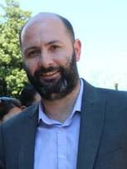
A native of Northern Ireland, Brendan received his Juris Doctor at The Catholic University of America in Washington DC, in January 2009. Focusing on the representation of foreign born nationals, and US employers with their US immigration matters, his work includes an emphasis on Extraordinary Ability and National Interest Waiver cases, as well as EB-1B, PERM, J-Waiver, H1B and O and P Visa applications. In addition, he has successfully utilized both the E and L Visa processes to assist investors and other companies start up companies here in the United States, as well as assisting them in transferring employees from foreign corporate offices to the US. Brendan works extensively with scientists, researchers, physicians, and other professionals, as well as organizations and employers in both academia and industry. He assists with their temporary and permanent visa applications on a company, individual, and institutional basis.

The fearless teaching framework: Evidence-based effective teaching

Marissa Stewart

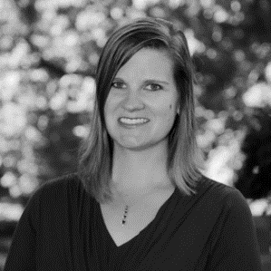
Originally from Chapel Hill, NC, Marissa attended a small liberal arts undergraduate institution, Davidson College near Charlotte, where she discovered how impactful good teaching can be. After graduating, Marissa went to The Ohio State University where she received her master’s and doctoral degrees in biological anthropology and archaeology. Her interest in providing resources for graduate students has led her to the position of Assistant Director for Graduate Programs at the TLTC. In the TLTC, Marissa is in charge of developing programming and support systems for the graduate and professional students at UMD. She plans and facilitates a variety of programs for graduate students, including the graduate student teaching orientation, teaching portfolio retreats, and teaching workshops.

Networking for introverts

Jeffrey Yeoung

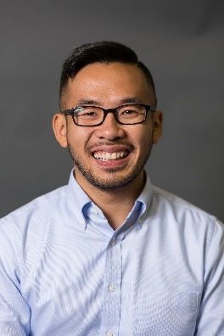
Jeffrey G. Yeung, M.A. (he/him/his) is a Ph.D. student in Counseling Psychology at the University of Maryland. He earned his undergraduate degree in psychology from the University of Illinois at Urbana-Champaign and his master's degree in special education from Loyola Marymount University. Prior to this graduate studies, he was a high school special education teacher in the Los Angeles Unified School District. His current research aims to understand the negative consequences of discrimination on the mental and physical health of both marginalized and dominant groups using an intersectionality perspective. As a psychologist-in-training, he has provided individual, group, and family psychotherapy in college counseling center, community mental health, private practice, and hospital settings. He is a proud Chicago native who enjoys new experiences, eating good food, and spending quality time with friends.

After the Postdoc – Transitions Panel
2:30-4:00 PM

Daryle Williams

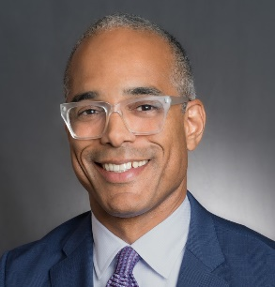
Daryle Williams (PhD, History, Stanford University, 1995), Associate Professor of History and Associate Dean for Faculty Affairs in the College of Arts and Humanities at the University of Maryland, is Co-Principal Investigator on AADHum and Enslaved, two collaborative projects in black studies and digital humanities sponsored by the Andrew W. Mellon Foundation. His current book project is "The Broken Paths of Freedom: Liberated Africans in Nineteenth-Century Brazilian Slave Society." Williams has held grants and fellowships from the National Endowment for the Humanities, the Fulbright Scholar Program, the Ford Foundation, the Rockefeller Humanities Fellowship Program, and the Maryland Institute for Technology in the Humanities. Prior to serving as an associate dean, Williams was graduate studies director in the UMD history department and associate director of the David C. Driskell Center for the Study of the African Diaspora.

Philip Staniczenko

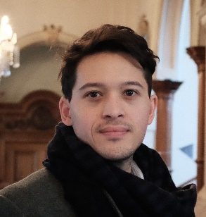
Phillip is an Assistant Professor of Biology at Brooklyn College and the Graduate Center, City University of New York, where he studies the effect of environmental change on species interactions and ecosystem services. He did his undergraduate and graduate degrees in physics at the University of Oxford, followed by a postdoc in ecology and evolution at the University of Chicago. He returned to the United Kingdom for a research fellowship in environmental risk at University College London, then crossed the Atlantic again for a research fellowship in social-ecological networks at the National Socio-Environmental Synthesis Center in Annapolis and the Department of Biology at the University of Maryland, College Park.

Mauricio Rangel-Gomez

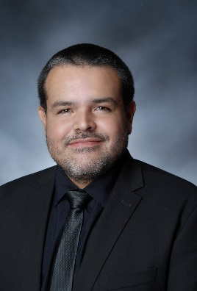
Mauricio Rangel-Gomez is a neuroscientist with expertise in electrophysiology, brain imaging, and neuropsychopharmacology. His most recent research focused on the understanding of the neural correlates of addiction to nicotine and how reduced nicotine content can alter the addictive potential of tobacco products. Rangel-Gomez held a postdoctoral fellowship at the Tobacco Center of Regulatory Science at the University of Maryland, College Park, where he studied the interactions among dopamine and nicotine and other components in electronic cigarettes. In 2018, Mauricio was granted the Tobacco Regulatory Science Fellowship and has been located at the Office of Science, within the Center for Tobacco Products, FDA. Rangel-Gomez has served as part of the organizing committee for the Tobacco Regulatory Science meeting and is a member of the Society for Research on Nicotine and Tobacco, the Society for Neuroscience, and the Cognitive Neuroscience Society. Additionally, he is an ad hoc reviewer for several neuroscience journals. Rangel-Gomez earned bachelor’s degrees in psychology (Universidad El Bosque) and engineering (Universidad de los Andes) in Colombia, and a master’s degree in neuropsychology (Maastricht University) and doctorate in cognitive neuroscience (Vrije Universiteit Amsterdam) in the Netherlands.

Shaun Gittens

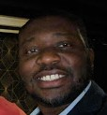
Dr. Shaun Gittens is the Director of the Machine Learning Capability of MasterPeace Solutions, Ltd., a company specializing in providing advanced technology and mission critical cyber services to its clients. Prior to joining MasterPeace, Dr. Gittens served as Principal Data Scientist for the Applied Technology Group, LLC. He built his career on the training and deployment of machine learning solutions on distributed big data and streaming platforms such as Apache Hadoop, Apache Spark, and Apache Storm. As a postdoctoral fellow at Auburn University, he investigated effective methods for visualizing the knowledge gained from trained non-linear machine learned models. Currently, Dr. Gittens often spends his free time volunteering whenever possible (i) at mentorship programs that look to provide guidance to at-risk urban youth and (ii) at programs that address STEM outreach for underrepresented populations. He received his B.S. in Applied Mathematics: Computer Science at the University of Rochester, M.S degree in Computer Science at Binghamton University, and his Ph.D. degree in Computer Science at the University of Maryland at College Park.

Katherine Johnson

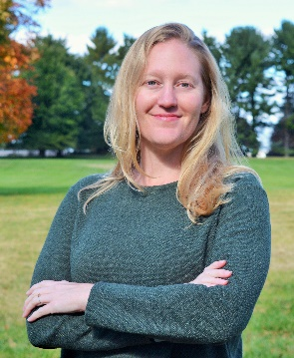
Dr. Johnson is currently an Earthquake Risk Mitigation Policy Analyst at the National Institute of Standards and Technology and graduated from the University of Maryland with her Ph.D. in Environmental Anthropology. Her career interest is to use qualitative research and policy analysis to assist communities in enhancing their resilience to natural hazards risks. Her current work in earthquake hazard risk mitigation and past work in a regional climate change adaptation project have reinforced her commitment to beneficial outcomes at the community-level. To achieve this, multidisciplinary collaboration is necessary across local, academic, and government sectors. Her personal goal is to continue to improve her techniques for effective collaboration, and her professional challenge is to strengthen and innovate methodologies with colleagues and in cooperation with communities.

